AU-LINK: An Integrated Student Academic and Administrative Management System with Predictive Grade Analytics

A Capstone Project
Presented to the Faculty of the
School of Computer Studies

In Partial Fulfillment of the
Requirements for the Degree in
Bachelor of Science in Information Technology

By:

De Guzman, Patrick P.
Rodriguez, Jonas V.
Sarigue, Kristene Margarette A.
Uy, Anthony Jonathan R.

OCTOBER, 2026
CHAPTER I
THE PROBLEM AND ITS BACKGROUND
This chapter provided an overview of the study, covering the background, problem statement, research questions, and objectives. It also detailed the study's scope and limitations, established its theoretical and conceptual frameworks, highlighted its significance, and defined key operational terms
- Introduction
In the contemporary landscape of higher education, the integration of digital systems has become essential for improving academic and administrative efficiency. Educational Institutions are increasingly adopting web-based technologies to streamline operations, enhance communication, and provide students with accessible and transparent services. However, the Computer Studies Department currently relies on fragmented and paper-based processes that result in delays, inefficiency, and security concerns.

Within the Computer Studies Department of Arellano University - Andres Bonifacio Campus, several academic and administrative procedures remain partially manual. Computer Studies students (BSCS and BSIT) often experience difficulties in monitoring their academic performances due to delayed access to grades and the lack of a centralized platform for academic monitoring. Additionally, the process for requesting official documents, such as Transcripts of Records (TOR) and certifications, involves physical submission and manual tracking, leading to long queues and potential delays in processing.

To address these challenges, this study proposes the development of an integrated Student Academic and Administrative Management System. The proposed web-based platform aims to centralize academic and administrative services, including learning management, grade transparency, and online document processing, into a single system. This study also incorporates Role-Based Access Control (RBAC) to ensure secure access management and Machine Learning through Linear Regression to provide predictive academic insights and early intervention support.

Through the implementation of this integrated system, the study seeks to promote operational efficiency, data security, transparency, and accessibility while supporting the university’s transition towards a more modern and paperless academic environment.

Background of the Study
The continuous evolution of educational technology has moved beyond simple classroom tools toward the total digitalization of both academic and administrative workflows. In modern higher education, the integration of systems is crucial for maintaining efficiency, security, and student satisfaction. However, many institutions, including Arellano University - Andres Bonifacio Campus, continue to face challenges due to fragmented processes where academic instruction and administrative requirements remain disconnected.

Currently, the Computer Studies Department utilizes an LMS to provide access to course materials and grades, but its full potential remains underutilized, leading instructors to rely on external platforms like Google Classroom for day-to-day tasks. This fragmentation forces Computer Studies students to switch between multiple platforms, complicating their academic experience. Beyond the classroom, the departmental administrative landscape remains heavily reliant on paper-based systems. For instance, the process for requesting official academic documents requires Computer Studies to physically visit the Registrar’s office, submit forms, and wait for manual processing. This method is not only time consuming but also creates bottlenecks during peak enrollment or graduation periods.

Furthermore, a "transparency gap" exists regarding academic performance. Computer Studies students often remain unaware of their actual grades for each term until final reports are issued. This "grade blindness" prevents students from monitoring their progress effectively and hinders early academic intervention.

To address these systemic issues, there is a critical need for an integrated web-based platform that centralizes both academic and administrative functions. By implementing automated grade computation and predictive machine learning models, such as Linear Regression, the system can provide students with real-time transparency and foresight into their academic standing. Transitioning to a unified system that handles LMS materials, grade monitoring, and online document requests will streamline university operations and provide a more secure, transparent, and efficient environment for Computer Studies students, faculty, and administrators alike.

The primary reason for conducting this study is to bridge the widening gap between academic progress and administrative compliance within Arellano University - Andres Bonifacio Campus. While Learning Management Systems (LMS) have digitized classroom interactions, the administrative side of a student’s life, specifically document requests and grade monitoring, remains anchored in obsolete, paper-based methods. This study is driven by the need to resolve three critical areas of concern:

First, there is an urgent need to ensure data integrity and security. The current manual handling of student records and document requests is susceptible to human error and physical damage. By transitioning to a digital system, the researchers aim to provide a secure environment where academic records are authenticated and stored centrally, protecting the institution's data.

Second, the study aims to eliminate "Grade Blindness" and promote academic transparency. Currently, a student’s access to comprehensive grade history and curriculum progress is often fragmented. By integrating these modules, the system allows for automated grade computation and real-time viewing, ensuring that students are informed of their academic standing without delays.

Third, the researchers recognize the need for operational efficiency. The long queues at the Registrar’s office and the redundant trips Computer Studies students make for document requests are symptoms of an inefficient workflow. This study seeks to automate these requests and status notifications to save time for both the students and the school personnel.

Finally, the study introduces Machine Learning to shift university management from being purely record-keeping to being proactive. By providing predictive grade analysis, the system serves as a tool for early academic intervention, helping students improve their performance before the term ends. Ultimately, this study is conducted to create a unified, high-tech solution that mirrors the digital standards of modern education.

Statement of the Problem
Educational technology has advanced from basic classroom aids into fully digitalized academic and administrative operations. Modern universities now rely on integrated systems as a necessity to drive operational efficiency, safeguard data security, and elevate the overall student experience. Although Learning Management Systems have successfully digitized instruction, institutional administration continues to rely on archaic, paper-reliant methods for students' official document requests.
Facing this issue, a study is conducted to develop an integrated management system for Arellano University - Andres Bonifacio Campus to address the inefficiencies of current paper-based and fragmented processes.
The study sought to answer the following questions:
1. How can the integrated platform provide Computer Studies students with real-time access to automated grade computations and curriculum tracking to resolve "grade blindness" and improve academic awareness?

2. How can the system utilize Machine Learning (Linear Regression) to analyze current performance data and provide students with predictive final grade insights and early academic warnings?

3. How can the implementation of an online document request and automated notification system reduce manual labor for the Registrar and eliminate long queues for the student body?

4. How can the system effectively consolidate LMS features (learning materials and G-Classroom announcements) with administrative functions (documentation and grade monitoring) into a single, user-friendly web interface?

Objectives of the Study
General Objective
The primary objective of this study is to develop and implement AU-Link: An Integrated Student Academic and Administrative Management System with Predictive Grade Analytics for Arellano University - Andres Bonifacio Campus. The system aims to centralize learning resource management, ensure grade transparency, streamline online document requests, and utilize Machine Learning for predictive academic insights to promote administrative integrity and operational efficiency.

Specific Objectives
The following are developed / created /done:
1. To design and develop a centralized web-based portal that consolidates academic features (grade viewing and curriculum tracking) with administrative features (document requests) using PHP (Laravel) and MySQL.

2. To implement a seamless integration with Google Classroom, enabling the synchronization of course announcements, learning materials, and academic updates directly into the AU-LINK student dashboard to prevent platform fragmentation.

3. To develop an automated grade computation module that provides Computer Studies students with real-time access to their term grades and overall curriculum progress, resolving "grade blindness."

4. To integrate a Machine Learning model (Linear Regression) that analyzes current student performance to provide predictive final grade insights and trigger early academic intervention alerts.

5. To establish an online document request module that streamlines Registrar workflows and provides students with real-time, automated notifications regarding their document processing status.

6. To implement a secure Role-Based Access Control (RBAC) system that restricts system access and data management capabilities based on user roles (Admin, Registrar, Department Head, Faculty, and Student), ensuring data integrity and security.

7. To evaluate the developed system’s performance, usability, and reliability based on the ISO/IEC 25010 software quality standards.

Scope and Delimitation
Scope
The study covers the following components of the system:
- Student Information and Academic Module: This module provides Computer Studies students with a centralized dashboard for viewing curriculum progress, grades, and academic updates. It also includes access to learning materials and announcements integrated from external learning platforms.
- Predictive Analytics Module: This module utilizes Machine Learning (Linear Regression) to analyze student performance data and generate predicted final grades. It serves as an early warning system to identify Computer Studies students who may be at risk of failing.
- Document Request and Registrar Module: This module enables Computer Studies students to request official academic documents such as TOR and certifications online. It includes an administrative interface for processing requests and an automated notification system for updates and document availability.
- Administrative and Security Module: This module provides system administrators with tools to manage user accounts, roles, department data, and system logs. It ensures data integrity and security through audit trails and controlled access mechanisms.
- Technical Framework: The system will be developed as a web-based application using PHP (Laravel) for backend development, MySQL for database management, and HTML, CSS, and JavaScript for frontend design. The system will be accessible via desktop and mobile web browsers.

Delimitations
While the system is designed to be a comprehensive management tool, the following constraints and boundaries are established:
- Financial Transactions: The system will not process actual monetary payments (e.g., tuition fees or document fees). It will only track the "Paid" or "Unpaid" status as updated by the Accounting Department or through uploaded proof of payment for verification.
- Offline Access: As a web-based platform, the system requires an active internet connection to function. It does not support an offline mode for syncing data once a connection is re-established.
- External Integration Limits: While the system displays announcements or links related to Google Classroom, it will not have full API control to change grades or delete files directly within the Google environment; it functions primarily as a centralized viewing and management hub.
- Authentication Method: The system will rely on standard secure login credentials (Email and Password). It does not include biometric authentication (e.g., fingerprint or facial recognition) or hardware-based security keys.
- Machine Learning Accuracy: The predictive analytics for grades are based on historical and current term data. The system provides "predictions" and "warnings," not a guarantee of the final grade, as student performance can be influenced by external factors not captured by the system.

Theoretical Framework
The study is primarily based on the concepts of Role-Based Access Control (RBAC), Rule-Based Algorithms, Machine Learning through Linear Regression, and Web-Based Information Systems.
Role-Based Access Control (RBAC) is used to restrict system access based on user roles such as administrators, registrar personnel, faculty members, department heads, and students. This ensures that only authorized users can access and manage specific academic and administrative data, improving system security and preventing unauthorized modifications.

Machine Learning through Linear Regression is integrated into the predictive grade analytics module. The model analyzes existing student performance data such as quizzes, activities, and term grades to estimate possible final grade outcomes. This provides students with early academic warnings and helps promote timely academic intervention.

The study is also supported by the concept of Web-Based Information Systems, which enables centralized academic and administrative management through an online platform accessible through web browsers. This improves accessibility, transparency, operational efficiency, and digital record management within the university environment.

Conceptual Framework
A conceptual framework is a visual or written map showing key variables in a study and how they relate. By adapting established theories, it links abstract research questions to real-world systems, behaviors, and outcomes.

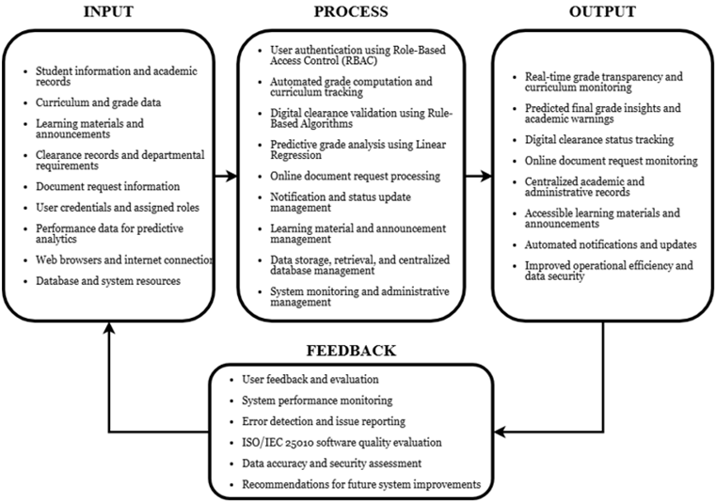

Figure 1: Input-Process-Output Model
Input
The input component consisted of the data, resources, and information required for the operation of the proposed system. These inputs provided the foundation for managing academic and administrative processes within the platform.
- Student information and academic records
- Curriculum and grade data
- Learning materials and announcements
- Document request information
- User credentials and assigned roles
- Performance data for predictive analytics
- Web browsers and internet connection
- Database and system resources

Process
The process component involved the procedures and system functionalities used to manage, validate, analyze, and store academic and administrative information within the platform.
- User authentication using Role-Based Access Control (RBAC)
- Automated grade computation and curriculum tracking
- Predictive grade analysis using Linear Regression
- Online document request processing
- Notification and status update management
- Learning material and announcement management
- Data storage, retrieval, and centralized database management
- System monitoring and administrative management

Output
The output component represented the services, information, and results generated by the proposed system after processing academic and administrative data.
- Real-time grade transparency and curriculum monitoring
- Predicted final grade insights and academic warnings
- Online document request monitoring
- Centralized academic and administrative records
- Accessible learning materials and announcements
- Automated notifications and updates
- Improved operational efficiency and data security

Feedback
The feedback component included the evaluation and monitoring mechanisms used to improve the performance, reliability, usability, and effectiveness of the proposed system.
- User feedback and evaluation
- System performance monitoring
- Error detection and issue reporting
- ISO/IEC 25010 software quality evaluation
- Data accuracy and security assessment
- Recommendations for future system improvements

Delimitations of the Study
The development of the AU-LINK: An Integrated Student Academic and Administrative Management System with Predictive Grade Analytics provided significant benefits to the following stakeholders:
Students - The proposed system provided students with a more convenient and accessible way of managing both academic and administrative tasks through a centralized web-based platform. It allowed students to access learning materials, monitor grades in real time, and request academic documents online. The predictive grade analytics feature may also help students identify academic risks early and encourage timely improvement in their performance.
Faculty Members - The system helped faculty members manage academic tasks more efficiently by providing tools for uploading learning materials, posting announcements, recording grades, and monitoring student progress in one platform. It reduces the need for repetitive manual processes and improves communication between instructors and students.
Registrar’s Office - The proposed system provided a more organized and efficient approach to handling document requests, and student records. It minimized paperwork, reduced long queues, prevented the loss of physical records, and allowed staff to process transactions more efficiently through digital workflows and automated notifications.
Department Heads and Administrators - The system provided authorized personnel with secure and centralized access to academic and administrative data through Role-Based Access Control (RBAC). It enabled department heads and administrators to monitor student records, generate reports, and improve overall management efficiency while reducing the risks associated with manual processing and signature forgery.
Arellano University – Andres Bonifacio Campus - The study contributed to the university’s digital transformation by introducing an integrated academic and administrative management platform. The implementation of the system promoted operational efficiency, transparency, accessibility, data security, and a more paperless environment for both students and university personnel.
Future Researchers - This study may serve as a reference for future researchers who plan to develop or improve integrated academic management systems, predictive grade analytics, and web-based educational technologies. It may also provide insights into the implementation of Machine Learning, Rule-Based Algorithms, and Role-Based Access Control in educational system development.

Operational Definition of Terms
The Definition of Terms section defines technical words and jargon used in the paper so readers can easily understand it. These are:
Academic Management System – A digital platform used to manage academic processes such as learning materials, grades, announcements, and curriculum monitoring.
Administrator – An authorized user responsible for managing the system, user accounts, permissions, and overall system operations.
Automated Grade Computation – A system feature that automatically calculates student grades based on encoded academic records and grading criteria.
Database – An organized collection of data used to store, manage, and retrieve information within the system.
Document Request System – A module that allows students to request official academic documents such as Transcript of Records (TOR), certificates, and other records online.
Google Classroom – A web-based learning platform developed by Google Classroom used for sharing assignments, announcements, and learning materials.
Grade Transparency – The accessibility and visibility of academic grades and performance records to students in real time.
Integrated Student Academic and Administrative Management System – A centralized web-based platform that combines academic and administrative services such as learning management, grade monitoring, and document requests into one system.
Learning Management System (LMS) – A software application used for delivering, managing, and monitoring educational content and classroom activities.
Linear Regression – A Machine Learning algorithm used to analyze relationships between variables and predict possible outcomes, such as students’ final grades.
Machine Learning – A branch of Artificial Intelligence (AI) that enables computer systems to learn from data and make predictions or decisions without explicit programming.
MySQL – A relational database management system used for storing and organizing system data.
Notification System – A feature that automatically sends updates or alerts to users regarding system activities, requests, or academic information.
Paperless System – A digital process that minimizes or eliminates the use of physical paper documents by using electronic records and transactions.
PHP (Laravel) – A web development framework used for building the backend functionalities and server-side logic of the system.
Predictive Analytics – The process of analyzing historical and current data to forecast possible future outcomes or trends.
Predictive Grade Analytics – A system feature that analyzes student academic performance data to estimate possible final grades and identify students at academic risk.
Registrar’s Office – The university department responsible for managing student records, academic documents, enrollment, and related administrative services.
Role-Based Access Control (RBAC) – A security mechanism that restricts system access based on the roles and permissions assigned to users.
Rule-Based Algorithm – A logical process that follows predefined rules and conditions to automate decision-making and validation within the system.
System Dashboard – A graphical user interface that displays system information, records, notifications, and user activities in an organized manner.
User Authentication – The process of verifying the identity of users before granting access to the system using login credentials such as email and password.
Web-Based System – A software application that operates through a web browser and requires internet access for functionality and accessibility.

CHAPTER II
REVIEW OF RELATED LITERATURE AND STUDIES
This chapter presents a comprehensive review of related literature and studies, encompassing both local and foreign sources, to establish the theoretical, conceptual, and technical foundation of this research.
- Review Related Literature
The continued adoption of web-based technologies in higher education has encouraged institutions to provide centralized digital platforms for academic and administrative services. These platforms allow users to access educational resources, academic information, and institutional services through online environments. In particular, Learning Management Systems (LMS) have become an important component of digital education because they support the delivery of learning materials, communication, assessment, and other academic activities. Tus et al. (2021) examined the use of Learning Management Systems among Filipino students during online learning and highlighted the role of LMS platforms in providing access to learning resources and supporting communication and academic activities.
The development of modern educational platforms has also emphasized the integration and organization of different academic functions within centralized systems. Ubaidah et al. (2026) examined the adoption of LMS features in higher education and identified factors related to the adoption process, including innovation characteristics, psychological and emotional factors, and the influence of the higher education environment. Their findings demonstrate that the effectiveness of an educational platform is influenced not only by the availability of features but also by how users perceive and adopt those features. This is relevant to AU-LINK because the proposed system combines several academic services into a centralized platform.
Learning Management Systems also require appropriate usability and user experience to support effective interaction between students and academic personnel. Laspiñas and Almerez (2024) examined the user experience of an LMS used by a higher education institution in Cebu, Philippines. Their study evaluated both pragmatic and hedonic qualities of the LMS and reported generally neutral user evaluations. The study emphasized the importance of interface design and user experience in the implementation of e-learning systems. Similarly, Llamas et al. (2025) examined the user experience of academics and students using a Moodle-based LMS and identified usability, communication, course building, monitoring and assessment, content management, and technical support as important areas for improvement. These findings support the need for AU-LINK to provide accessible and user-oriented academic functions.
The quality and functionality of Learning Management Systems can also vary depending on the features and services provided by the platform. Sanchez et al. (2024) compared 45 Learning Management Systems for higher education using criteria involving interoperability, accessibility, productivity tools, communication tools, learning tools, and security standards. Their findings demonstrate that LMS platforms can be evaluated based on both software quality and teaching-learning functionality. This supports the integration of learning resources, communication, assessment, and security-related functions within educational information systems.
Student Information Systems are another important component of digital academic management because they provide centralized mechanisms for organizing and maintaining student records. Campanan et al. (2024) developed IntelliSchool, a Student Information System for senior high school that aimed to improve data accuracy and consistency, provide paperless web-based class records, promote transparency in form generation, and improve communication between the school and parents. The study demonstrates how web-based student information systems can support the organization and accessibility of academic information.
Academic assessment and grade management can also be supported through integrated web-based systems. Yussuff et al. (2024) developed an integrated web-based continuous assessment management system to support the management of student assessments. Their study addressed the use of computerized systems for handling continuous assessment activities and demonstrated the potential of web-based systems to support academic assessment processes. Banag (2024) likewise developed a user-centered Grade Management Information System for a private school in Cavite, Philippines. The system was designed to manage student grades and was evaluated in terms of functional suitability, performance efficiency, reliability, security, maintainability, portability, and usability. These studies support the inclusion of centralized grade management and automated academic processes within AU-LINK.
Digitalization has also extended to administrative services in higher education. Casicas et al. (2024) developed an Online Document Requisition System for PHINMA College of Cagayan to streamline the requesting, management, and accessing of institutional documents. The study demonstrates how online document-request platforms can reduce dependence on manual procedures and provide students with a more accessible way to process institutional documents. This concept is relevant to AU-LINK's Document Request and Registrar Module, which provides students with an online mechanism for requesting official academic documents.
The increasing use of centralized educational systems also requires appropriate mechanisms for protecting academic and personal information. Role-Based Access Control (RBAC) provides a method for managing system permissions according to user roles. Kabier et al. (2023) examined the use of RBAC in educational systems and proposed an approach in which system privileges are managed according to user roles. Their study emphasized access control as an important component of security in educational information systems. This is relevant to AU-LINK because the proposed system provides different levels of access to students, faculty members, department heads, registrar personnel, and administrators.
Another important development in educational information systems is the use of predictive analytics and machine learning to analyze student performance. Adnan et al. (2021) examined the use of machine learning and deep learning for predicting learner performance and discussed how prediction can support early intervention for students who demonstrate weaker academic performance. More recent research has continued to examine machine learning applications in higher education. Chen et al. (2025) conducted a systematic literature review on the application of machine learning in higher education, focusing on the prediction of student performance, learning engagement, and self-efficacy. These studies demonstrate the potential of educational data and machine learning techniques to provide insights that can support academic decision-making and early intervention.
The application of predictive analytics can also be integrated directly into web-based academic systems. Cruz and Lumauag (2025) developed a web-based student academic performance prediction system using machine learning for higher education institutions. Their study focused on developing and integrating a machine-learning approach into a real-time web application for identifying students who may be at risk academically. This demonstrates the feasibility of incorporating predictive analytics into a web-based academic environment. AU-LINK applies a similar concept by integrating predictive grade analytics into a broader student academic and administrative management platform.
Overall, the reviewed literature indicates that modern educational information systems increasingly emphasize centralized access to academic information, LMS functionality, assessment and grade management, digital administrative services, security, usability, and predictive analytics. These developments provide a foundation for the design of AU-LINK as an integrated student academic and administrative management system that combines these functions within a single web-based platform.
- Review Related Studies
Campanan et al. (2024) developed IntelliSchool, a Student Information System for senior high school in the Philippines. The system was designed to improve the accuracy and consistency of student information, provide paperless web-based class records, improve transparency in generating forms, and enhance communication between schools and parents. The researchers implemented the system using a rapid application development approach and evaluated its functionality and usability. The study demonstrates the usefulness of centralized student information systems in managing academic information. However, its scope primarily focused on student information management and communication and did not incorporate predictive grade analytics or an integrated online academic document-request process.
Pasaribu and Argadikusuma (2024) developed and tested a Web-Based Student Information Management System for Politeknik Piksi Ganesha Bandung. The system was designed to manage student information through a web-based environment, with its functional and non-functional requirements represented using Unified Modeling Language. The study demonstrates the application of web technologies for organizing and managing student data in higher education. However, the system primarily focused on student information management and did not integrate predictive academic analytics, LMS functions, and online document requests into one platform.
Yussuff et al. (2024) developed an Integrated Web-Based Continuous Assessment Management System to support the management of student assessment activities. The study addressed the need for computerized management of continuous assessment and demonstrated the usefulness of web-based systems for handling academic assessment processes. Its focus was primarily on assessment management rather than providing a comprehensive student management platform. AU-LINK extends this concept by incorporating academic assessment and grade management together with curriculum monitoring, learning-management functions, administrative document requests, and predictive grade analytics.
Banag (2024) developed a user-centered Grade Management Information System for a private school in Cavite, Philippines. The system was designed to manage student grades and was evaluated using software-quality characteristics including functional suitability, performance efficiency, reliability, security, maintainability, portability, and usability. The study demonstrates the importance of automated grade management and user-centered design in academic systems. However, the system focused specifically on grade management and did not combine grade management with LMS functions, online document requests, and predictive grade analytics.
Laspiñas and Almerez (2024) investigated the user experience of a Learning Management System used by a higher education institution in Cebu, Philippines. Their study assessed pragmatic and hedonic qualities of the LMS and found generally neutral user evaluations. The researchers emphasized the relevance of interface design in implementing an effective e-learning system. While the study provides useful findings regarding LMS usability and user experience, its focus was limited to the LMS environment rather than an integrated academic and administrative management system.
Llamas et al. (2025) investigated the needs and challenges of academics and students using a Moodle-based Learning Management System. Through a qualitative user-experience approach, the researchers identified usability, communication, course building, monitoring and assessment, content management, and technical support as important areas affecting the LMS experience. The study provides evidence that LMS development should consider both functional requirements and the experiences of its users. However, the study focused on improving the user experience of an LMS rather than integrating LMS functions with student information management, predictive analytics, and online administrative document processing.
Ubaidah et al. (2026) examined LMS feature adoption in higher education by investigating innovation attributes, psychological and emotional factors, and the social environment surrounding LMS use. The study demonstrates that the successful adoption of educational technologies depends on more than simply providing system features. User perception and institutional conditions also influence how educational technologies are adopted. However, the study primarily investigated LMS feature adoption rather than developing an integrated student academic and administrative management system.
Cruz and Lumauag (2025) developed a Web-Based Student Academic Performance Prediction system using machine learning for higher education institutions. The study introduced a practical machine-learning approach that was integrated into a real-time web application to predict student academic performance and identify students who may be academically at risk. The study demonstrates the feasibility of integrating predictive analytics into a web-based educational environment. However, the system focused primarily on academic performance prediction and did not combine predictive analytics with student information management, LMS functions, curriculum monitoring, and online academic document requests.
Casicas et al. (2024) developed ODR.REGISTRAR-COC.EDU.PH, an Online Document Requisition System for PHINMA College of Cagayan. The system was designed to streamline the process of requesting, managing, and accessing institutional documents. The study demonstrates how digital document-request systems can provide a more accessible alternative to manual document processing. However, its focus was on document requisition and registrar-related processes rather than integrating these functions with academic management, LMS capabilities, and predictive academic analytics.
Kabier et al. (2023) examined the use of Role-Based Access Control in educational systems to improve security and manage user privileges. Their proposed educational system assigned permissions according to user roles and incorporated authentication mechanisms to control access to system resources. The study demonstrates the importance of role-based security in educational information systems. However, its primary focus was security and access control rather than the development of a comprehensive academic and administrative management platform.
- Synthesis
The reviewed studies demonstrate that various educational information systems have successfully addressed individual aspects of academic and administrative management. Campanan et al. (2024) and Pasaribu and Argadikusuma (2024) focused on centralized student information management, while Yussuff et al. (2024) and Banag (2024) addressed academic assessment and grade management. Laspiñas and Almerez (2024), Llamas et al. (2025), and Ubaidah et al. (2026) examined LMS usability, user experience, and feature adoption. Cruz and Lumauag (2025) focused on web-based academic performance prediction using machine learning, while Casicas et al. (2024) addressed online document requisition. Kabier et al. (2023) focused on security through role-based access control.

Although these studies provide valuable solutions for specific academic, administrative, or technical requirements, the reviewed systems generally address these functions separately. The studies reviewed do not demonstrate the same combination of centralized student academic management, LMS-related functions, curriculum monitoring, online academic document requests, role-based access control, and predictive grade analytics within a single platform. This gap provides a basis for the development of AU-LINK, which seeks to integrate these academic and administrative functions into one centralized web-based system for the target university environment.

CHAPTER III
METHODOLOGY
This chapter presented the research design, development methodology, respondents, data gathering instruments, development tools, system architecture, evaluation procedure, data analysis, and ethical considerations that guided the innovation and testing of the system. The methods outlined here are carefully selected to align with the project’s objectives and ensure that the final output met both academic and operational standards.
- Research Design
The study utilized an Applied Developmental Research method. This methodology was selected because the study concerns the application of problem-solving techniques as well as software development. From the aspect of applied research, the study aimed at addressing specific issues within the Arellano University Andres Bonifacio Campus such as inefficiency, delays in accessing grades, and repetitive paperwork requirements. The main objective is to design a solution in the form of a software product to overcome the issues described above.

As a developmental research approach, the study followed an iterative process of designing, building, and refining a web-based prototype. This allowed the researchers to develop the system in modules, incorporate user feedback during testing, and ensure that features like the predictive grade analytics are functional, secure, and user-friendly before final deployment. By combining these two approaches, the study ensured that the output is not only technically robust but also practically useful for the university community.

- Data Collection
The study utilized feedback statements as the primary instrument for collecting data from respondents. This structured set of statements is adapted from the ISO/IEC 25010 software quality standard and designed to gather quantitative feedback on the system's performance and quality. The evaluation utilized a 4-point Likert scale ranging from 1 (Strongly Disagree) to 4 (Strongly Agree), allowing respondents to rate their level of agreement with statements about the system's functionality, usability, reliability, security, and overall user experience. The instrument is administered exclusively to information technology students as users after they completed hands-on testing sessions with the platform. By using standardized statements, the researchers are able to collect consistent, measurable data from the student perspective, which facilitated objective analysis of the system's strengths and areas for improvement. The responses gathered through this instrument served as the basis for evaluating whether the system met the ISO/IEC 25010 quality benchmarks from the respondents’ point of view.
- System Development Life Cycle
The System Development Life Cycle (SDLC) is the step-by-step methodological framework used to plan, design, build, test, and deploy a software application or IT system. It serves as the scientific blueprint that guides how the technological solution is developed to address the core research problem.

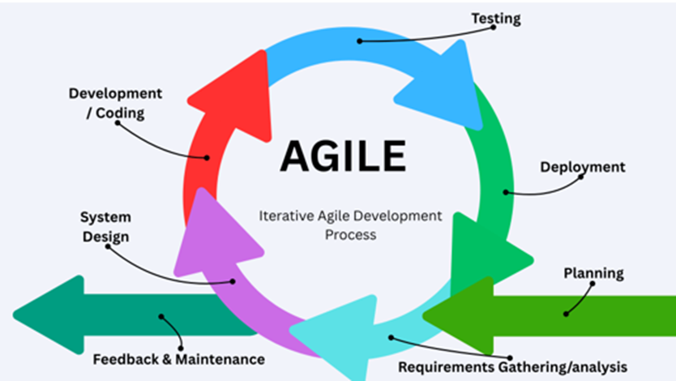

Figure 2: SDLC Model
The researchers applied the Agile Software Development Life Cycle (SDLC) to guide the development of the system. Agile is chosen because it supported iterative development, allowing the team to build, test, and refine the platform in manageable cycles rather than attempting a single, rigid rollout. This approach is aligned well with the project’s modular structure, where features like the grade computation module, and predictive analytics engine can be developed and validated independently before full integration.
The development process is organized into four-week sprints, each focusing on a specific set of deliverables. The initial phase involved requirements gathering and workflow mapping with key stakeholders (students, faculty, and registrar staff) to ensure the system addressed real campus pain points. During the design and development sprints, the backend (Laravel), database (MySQL), and frontend interfaces are built concurrently, with continuous integration to prevent compatibility issues. Each module underwent unit testing and peer review before moving to user acceptance testing. Feedback from these testing cycles is immediately incorporated into succeeding sprints and calibrating the Linear Regression model for grade predictions. This iterative, feedback-driven methodology ensured that the final system remained functional, user-centered, and aligned with the university's operational standards.
- Database Design
Database design is a systematic process used to develop, implement, and maintain a structured data management system. Its primary purpose is to create both logical and physical models that define how data is organized, stored, and accessed to meet the functional requirements of the system.
The section presented the structural design and data flow of the system. It illustrated how student information, academic records, and administrative processes are integrated through the web-based platform with predictive analytics capabilities.
- Context Diagram
A context diagram is a top-level architectural visual that represents an entire software, hardware, or information system as a single central process, surrounded by the external entities that interact with it. It provides a high-level view of the system, explicitly establishing what sits inside the system's boundary and what lies outside.
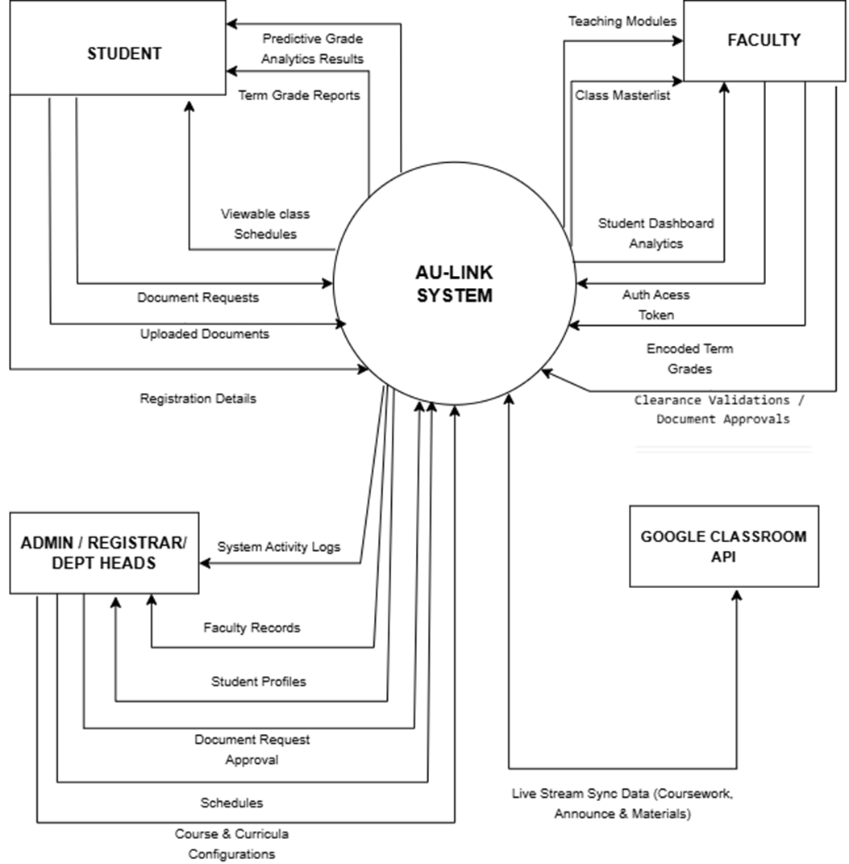
Figure 3: Context Diagram
The context diagram illustrated the high-level boundaries of the system and its interaction with five primary external entities: Students, Faculty, Department Heads, Registrar Staff, and Administrators. The diagram defined the flow of data into and out of the system. Inputs included login credentials, grade records and document processing updates. Output generated by the system included real-time grade, request queues, system reports, and audit logs. This diagram established the scope of the system, showing how it served as the central hub for academic and administrative data exchange.
- Data Flow Diagram
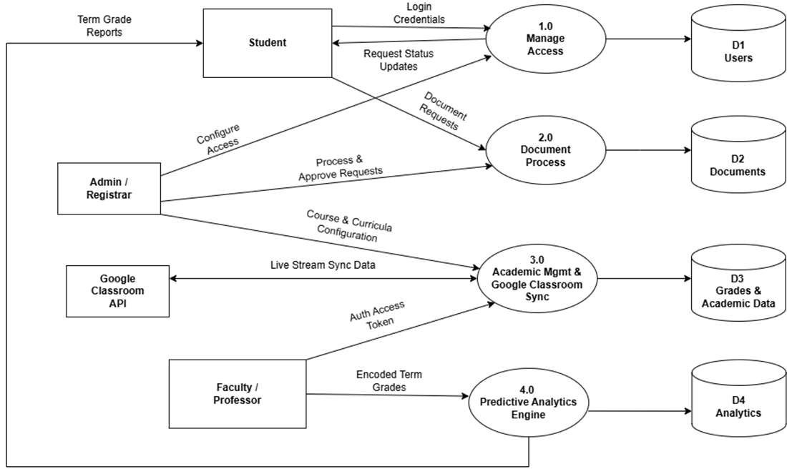
A Data Flow Diagram (DFD) is a graphical representation of how information moves through an information system or software model. It maps out where data originates (inputs), how it gets processed and transformed, where it is stored, and where it ultimately goes (outputs). A DFD focuses strictly on the flow and processing of data, omitting control flow logic like decision loops, sequence order, or conditional branching.

Figure 4: Data Flow Diagram (Level 0)
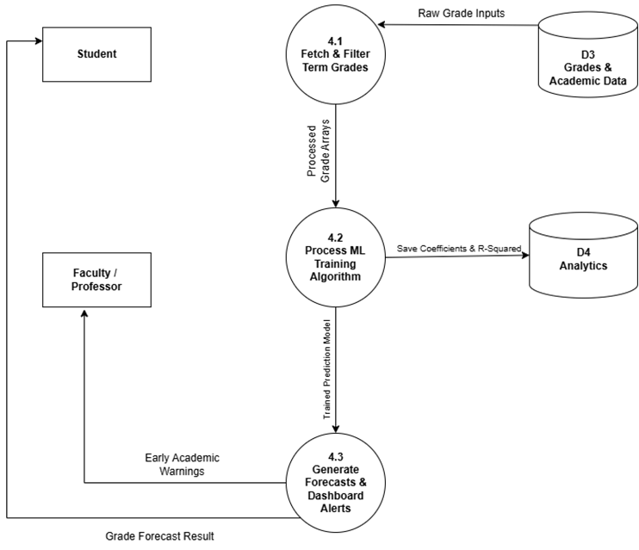
The DFD Level 0 showed how the system worked. It has five main processes: (1.0) Manage Access for login, (2.0) Academic Management for grades, (3.0) Document Process for online requests, and (4.0) Predictions for grade forecasting. Students, Faculty, Department Heads, Registrar, and Admins interacted with these processes by sending requests and receiving outputs. Each process saved and retrieved data from its own database (D1 to D5). Process 2.0 and 5.0 worked together to generate predicted grades using Linear Regression. This diagram showed how the system connected all academic and administrative tasks in one system.

Figure 5: Data Flow Diagram (Level 1)

This diagram showed how the Student interacted with the system. The student logs in, applied for documents, and viewed grades. Each action goes through a process (like Grade Management) that saves or checks data in storage. The system then sends back results like approval status, document alerts, or grade reports.
- Entity Relationship Diagram
An Entity Relationship Diagram (ERD) is a structural model that visually maps how distinct data objects (entities) connect and interact with one another inside a system's database architecture. An ERD acts as the conceptual blueprint for a relational database.

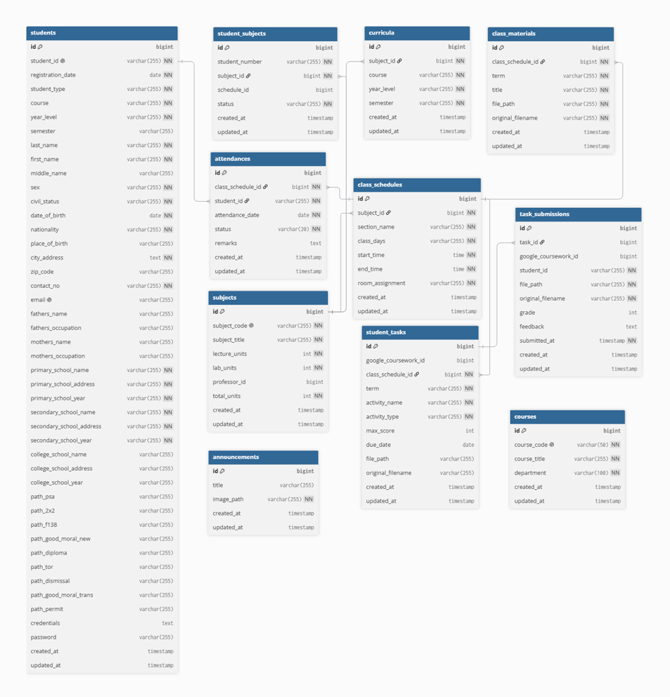

Figure 6: Entity Relationship Diagram

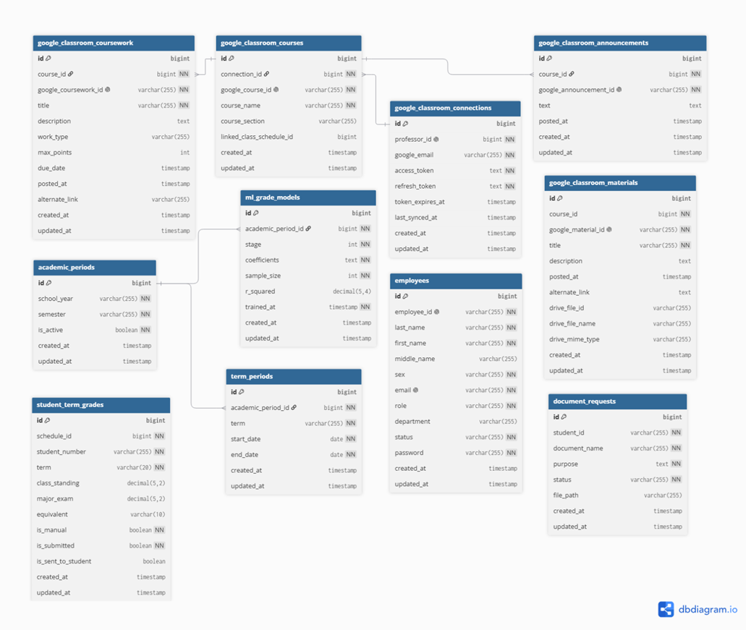

Figure 7: Entity Relationship Diagram
The ERD represents the database structure of the AU-LINK Student Management System. It organizes student information through the Students table and academic programs through the Courses table, while the Subjects and Curricula tables manage subject offerings according to course, year level, and semester. The Employees table manages faculty members and administrative personnel, while Class Schedules and Student Subjects organize subject offerings and student enrollment. The system also includes tables for attendance, term grades, learning materials, student tasks, and task submissions to support academic and learning management functions. Google Classroom integration is supported through dedicated tables for courses, announcements, coursework, materials, and account connections. In addition, Academic Periods and Term Periods manage academic timelines, while the ML Grade Models table supports predictive grade analytics. The Document Requests and Announcements tables provide administrative and communication functions. Overall, the database design provides a structured and centralized framework for managing student information, academic records, learning resources, predictive analytics, and administrative processes while maintaining organized relationships among the system's core entities.

- Use Case Diagram
A Use Case Diagram is a high-level visual model from the Unified Modeling Language (UML) that illustrates how users interact with a proposed software system, application, or platform. It maps out the functional requirements by showing the relationships between different entities (actors) and the actions or processes they perform (use cases).

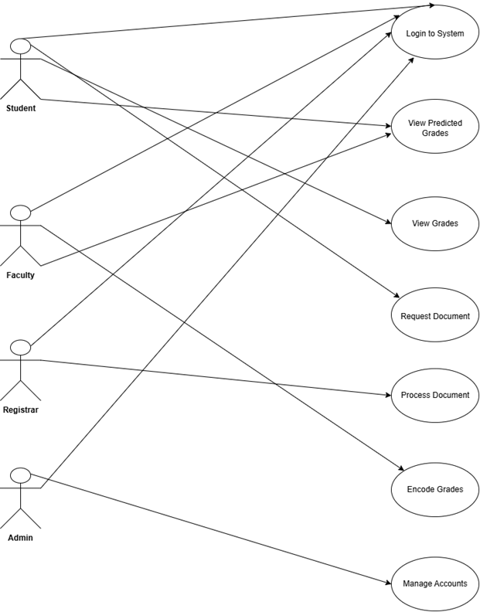

Figure 8: Use Case Diagram
The Use Case Diagram illustrated the interactions between five actors and the system. The Student actor can login, view grades, check predicted grades, and apply for documents. The Faculty member can login, encode grades, and upload learning materials. The Department Head can login and approve or reject requests. The Registrar staff can login, process document requests, and update request statuses. The Administrator can login, manage user accounts, assign roles, and view system logs. All actors must authenticate through the login use case before accessing their respective features. The diagram showed how each actor interacts with specific system functionalities based on their role and permissions.
- Hierarchy Input Process Output (HIPO) Diagram
The Hierarchy Input Process Output (HIPO) diagram presents the hierarchical structure of the AU-LINK system and illustrates the inputs, processes, and outputs associated with its major functions. The system is divided into five major modules: Manage Access, Academic Management, Document Processing, Predictive Grade Analytics, and System Administration. Each module is further decomposed into its corresponding inputs, processes, and outputs.

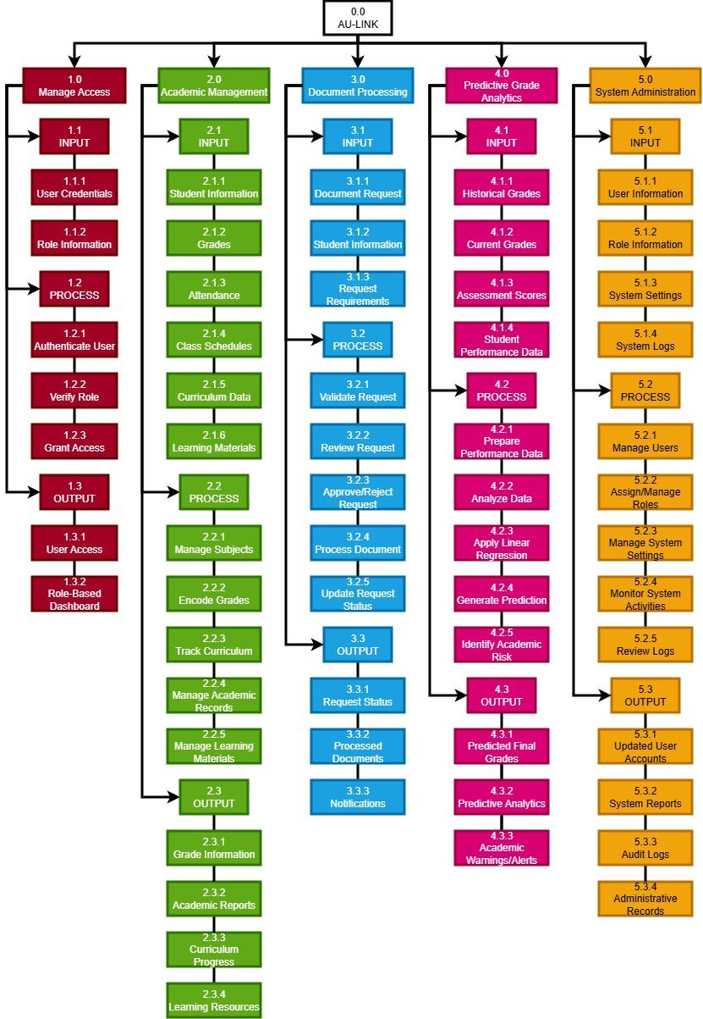
Figure 9: Hierarchy Input Process Output (HIPO) Diagram

Software Requirements

The table below shows the tools used in the development of the system.
Software | Description | Purpose
Php (Laravel Framework) | Backend web development framework | Used for developing the system’s server-side functions and application logic.
MySQL | Relational Database Management System | Used for storing and managing system data.
HTML/CSS/JavaScript | Frontend development technologies | Used for designing and developing the user interface.
Visual Studio Code | Source code editor | Used for coding, debugging, and system development.
Xampp | Local development server environment | Used for running Apache and MySQL locally during development.
Github | Version control platform | Used for source code management and collaboration.
Any Modern Web Browser (e.g., Google Chrome, Microsoft Edge, Safari) | Web Browsers | Used for testing and accessing the system.

Table 1: Development Tools

Shown is a table of hardware requirements.
Hardware Components | Minimum Requirement
Processor | Intel Core i3 or equivalent
RAM | 4GB
Storage | 128GB (SSD or HDD)
Operating System | Windows 10 or higher
Internet Connection | Stable broadband connection (at least 5 Mbps)

Table 2: Hardware Requirements Table
- Evaluation Procedure
To systematically assess the quality, performance, and overall acceptability of the AU-LINK system, a descriptive research evaluation procedure will be conducted. The evaluation will utilize the structured ISO/IEC 25010 Software Quality Product Model as its primary framework, ensuring a comprehensive analysis from both operational and technical perspectives.
The evaluation process will be divided into two main components to gather well-rounded feedback from distinct groups of respondents:
- User Acceptance Evaluation: This phase focuses on the operational and practical aspects of the system. End-users, including students and academic administrators, will evaluate characteristics that directly affect their user experience, such as Functional Suitability, Performance Efficiency, and Usability. This ensures that the academic tracking features and predictive analytics are intuitive, responsive, and aligned with the user needs.

- Technical Expert Evaluation: This phase focuses on the architectural integrity and structural quality of the application. IT professionals, software engineers, and capstone panel members will rigorously assess the technical dimensions of the software, specifically focusing on Security (validating the Automated Role-Based Access Control and MySQL safety), Reliability (fault tolerance and stability), Maintainability (the modularity and clean coding of the Laravel framework), and Portability (cross-device responsiveness and deployment flexibility).

All gathered data from the evaluation forms will be collated, statistically treated using the weighted mean, and interpreted to determine the final quality and deployment readiness of the AU-LINK system.

Evaluation Tool

The primary research instrument for this study is an evaluation questionnaire using the ISO 25010 software quality standards.
Shown below is the ISO 25010 evaluation form:
Legend: 4- Strongly Agree 3 – Agree 2 – Disagree 1 – Strongly Disagree

CRITERIA | SA (4) | A (3) | DA (2) | SDA (1)
1. Functionality
1.1 The system provides all the features.
1.2 The system's functions are appropriate for the users' actual needs.
2. Performance
2.1 The system loads pages and processes requests quickly.
2.2 Generates reports with acceptable results
3. Compatibility
3.1 The system works correctly on different web browsers (Chrome, Edge, Firefox).
4. Usability
4.1 The user interface is clean, visually appealing, and easy to navigate.
4.2 It is easy to learn how to use the system without needing a manual.
4.3 Error messages, labels, and instructions are clear and helpful.
5. Reliability
5.1 The system does not crash or encounter fatal errors during use.
5.2 The system recovers from errors without losing data.
6. Security
6. 1 The login process is secure and protects user accounts.
6.2 Sensitive data (e.g., grades, personal records) appears protected from unauthorized access.
6.3 The system properly restricts access based on user roles (e.g., students cannot access admin functions).

Table 3: The ISO 25010 Evaluation Form For Users

CRITERIA | SA (4) | A (3) | DA (2) | SDA (1)
1. Functionality
1.1 The system correctly implements all specified functional requirements.
1.2 The system produces accurate and consistent output/results.
2. Performance
2.1 The system responds quickly under normal and peak load.
2.2 The system handles multiple concurrent users without degradation.
3. Compatibility
3.1 The system works correctly across supported browsers.
4. Reliability
4.1 The system operates stably without crashes or fatal errors.
4.2 Backup and recovery mechanisms protect against data loss.
5. Security
5.1 Authentication and role-based access control are properly enforced.
5.2 The system is protected against common web vulnerabilities (e.g., SQL).
6. Maintainability
6. 1 The source code is well-structured, follows coding standards, and is easy to update.
6.2 Technical documentation (system design, database schema, deployment guide) is complete and up to date.

Table 4: The ISO 25010 Evaluation Form for Technical
- Respondents of the Study

The study involved two groups of respondents: (a) user respondents and (b) technical experts.
The user respondents consisted of 40 individuals composed of: (1) 30 information technology students (CS/IT); and (2) 10 administrative personnel (professors, department heads, department secretary and registrar staff). These respondents are selected because of their direct involvement with the system as end-users. They evaluated the system based on usability, interface design, functionality, and how well it supports their daily tasks from a user experience perspective.
The technical experts are composed of 10 individuals, consisting of Information Technology (IT) professionals such as developers, system analysts, and graduates of computer studies. They assessed the system’s technical quality, focusing on performance, reliability, maintainability, and security, aligning with ISO 25010 software quality standards.
Purposive sampling technique is used, meaning respondents are chosen based on their relevance to the study rather than random selection.
A total of 50 respondents participated in the evaluation phase of this study.
- Statistical Tools
The following statistical tools are used in the study:
- Frequency Distribution (Relative Frequency)
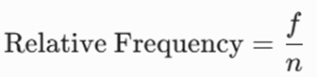
The standard frequency is the raw count (f) of how often a value occurs, and the relative frequency shows the proportion of the total data set that the value represents.

Where:
f = The frequency of an individual score or category
n = The total number of scores or the total sample size (sum f)
- Percentage Distribution
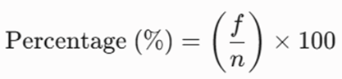
The percentage distribution converts the relative frequency into a percentage, making it easier to compare categories regardless of the total sample size. The formula is shown below:

Where:
P = Percentage
f = Frequency of responses
n = Total number of respondents

Weighted Mean

A weighted average, also known as a weighted mean, is a computation that takes into account the differing reliability, frequency, or significance of several data points in a study.

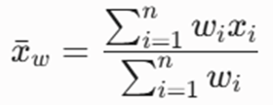
A weighted mean gives some values more "say" according to predetermined criteria, in contrast to a simple average where all numbers have the same weight. The formula is shown below:

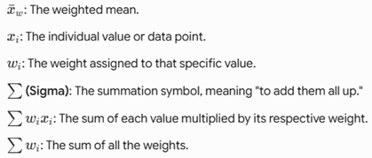
Where:

- Likert Scale
The Likert scale is a widely used tool in quantitative research and evaluation for measuring individuals’ attitudes, opinions, or perceptions. It consists of a series of statements or questions to which respondents indicate their level of agreement. Each response is assigned a numerical value, enabling statistical analysis of the results. For this study, a 4-point Likert Scale is employed, with values ranging from 4 (“Strongly Agree”) to 1 (“Strongly Disagree”). The corresponding scale is presented in the table below:
Weighted Point | Scale | Difference | Verbal Interpretation
4 | 3.01-4.00 | 0.99 | Strongly Agree
3 | 2.01-3.00 | 0.99 | Agree
2 | 1.01-2.00 | 0.99 | Disagree
1 | 0.99-1.00 | 0.01 | Strongly Disagree

Table 4: The 4-Point Likert Scale

References
Altabrawee, H., Ali, O., Ajmi, S. (n.d.). Predicting Students’ Performance Using Machine Learning Techniques. Journal of Babylon University. https://www.journalofbabylon.com/index.php/JUBPAS/article/view/2108

Banag, C. T. (2024). User-Centered Design and Development of a Grade Management Information System of a Private School in Cavite, Philippines. https://ijrehc.com/uploads2024/ijrehc05_13.pdf

Bala, M. (2025). Design And Implementation Of A Web-Based Information System For University Staff Union. ResearchGate. https://www.researchgate.net/publication/391233821_DESIGN_AND_IMPLEMENTATION_OF_A_WEB-BASED_INFORMATION_SYSTEM_FOR_UNIVERSITY_STAFF_UNION

Campanan, A. M. F., Bermejo, R. M. M., & Madrigal, D. V. (2024). IntelliSchool: A Student Information System for Senior High School. https://techniumscience.com/index.php/technium/article/view/10816

Casicas, R., Castro, R., Macaindig, M., & Labadan, M. (2024). ODR.REGISTRAR-COC.EDU.PH: Online Document Requisition System. https://www.researchgate.net/publication/389063626_ODRREGISTRAR-COCEDUPH_ONLINE_DOCUMENT_REQUISITION_SYSTEM

Chen, J., Zhou, X., Jiahua, Y., & Tang, S.-K. (2025). Application of machine learning in higher education to predict students’ performance, learning engagement and self-efficacy: A systematic literature review. https://www.sciencedirect.com/org/science/article/abs/pii/S2046316225000136

Computer Security Division, Information Technology Laboratory, National Institute of Standards and Technology, U.S. Department of Commerce. (n.d.). Role Based Access Control. CSRC. https://csrc.nist.gov/projects/role-based-access-control

Cruz, M. M. P., & Lumauag, R. G. (2025). Development of a Web-Based Student Academic Performance Prediction Using Machine Learning for Higher Education Institutions. https://www.researchgate.net/publication/394305220_Development_of_a_Web-Based_Student_Academic_Performance_Prediction_Using_Machine_Learning_for_Higher_Education_Institutions

Davis, F. D. (n.d.). Technology Acceptance Model (TAM). https://open.ncl.ac.uk/theories/1/technology-acceptance-model/

Fruhlinger, J. (2025). What is the CIA triad? A principled framework for defining infosec policies. CSO Online. https://www.csoonline.com/article/568917/the-cia-triad-definition-components-and-examples.html

International Organization for Standardization. (n.d.). Systems and software engineering — Systems and software Quality Requirements and Evaluation (SQuaRE). System and software quality models (ISO/IEC 25010:2011). https://www.iso.org/standard/35733.html

Kabier, M. K., Yassin, A. A., & Abduljabbar, Z. A. (2023). Towards for Designing Educational System Using Role-Based Access Control.

Laspiñas, R., & Almerez, A. U. (2024). Users' Experience Study on the Learning Management System of a Higher Education Institution in Cebu, Philippines.
https://ejournals.ph/article.php?id=25440

Llamas, M. C. A. R., Vilela-Malabanan, C. M., & Dinawanao, D. D. (2025). Needs and challenges of academics and students in using a learning management system: A user experience approach. https://edulearn.intelektual.org/index.php/EduLearn/article/view/22350/10954

Sanchez, L., Penarreta, J., & Soria Poma, X. (2024). Learning management systems for higher education: A brief comparison.
https://link.springer.com/article/10.1007/s44217-024-00143-5

Selim, H. M. (n.d.). Critical Success Factors for E-Learning Acceptance: Confirmatory Factor Models. https://www.scirp.org/reference/referencespapers?referenceid=4058711

Ubaidah, U., Budiono, TA., Darmadi, H., and Sukmono, A.N. (2026). Multi-lens analysis of LMS feature adoption in higher education. ResearchGate. https://www.researchgate.net/publication/399763239_Multi-lens_analysis_of_LMS_feature_adoption_in_higher_education

Venkatesh, V. et al. (n.d.). Unified Theory of Acceptance and Use of Technology (UTAUT). https://open.ncl.ac.uk/theories/2/unified-theory-of-acceptance-and-use-of-technology/

Yussuff, A. I. O., Goke, A., Folorunsho, H. B. and Adedoyin, M. A. (2024). Development of Integrated Web-Based Continuous Assessment Management System. https://journals.uniosun.edu.ng/ujees/article/view/402/363

